REC-MURA.04B
Surgery/Procedure Clinical Trial Protocol Template for Ramathibodi EC Submission
Based on STANDARD PROTOCOL ITEMS: RECOMMENDATIONS FOR INTERVENTIONAL TRIALS (SPIRIT) 2025 checklist (https://doi.org/10.1016/ S0140-6736(25)00770-6)
(All information can be written in Thai or English. Descriptions in red must be deleted before submission)
หมายเหตุ: ห้ามตัดหัวข้อออก คงไว้ตามแบบฟอร์ม หากไม่มีข้อมูลที่เกี่ยวข้อง ให้ระบุว่า” ไม่มี” (ตัดเฉพาะคำอธิบายสีแดงออก) และสามารถระบุรายละเอียดเป็นภาษาไทยได้
Study Title (English):
Study Title (Thai):
Principal investigator: | <please include name, affiliation and contact data, signed and dated CV is required in separate documents>
Co-investigator(s): | <please include name, affiliation and contact data, signed and dated CVs of all co-investigators are required in separate documents>  <Please remark who is the major advisor for student/resident research project>
Sponsor or planned sponsor, grant, scholarship <if applicable>: | - Detail all sources and types of financial, material, and other support.  - Name and contact information for the trial sponsor or intended funding sources.  - please note that Mahidol University do not allow using of healthcare insurance or beneficiary for research purpose. If the investigator believes that all study procedures in the study are within reimbursable standard of care, please enclose letter of confirmation from the head of the department. >
Conflict of Interest: | < describe any potential issue that the outcome of the research may lead to a investigators’ personal advantage, and that might compromise the integrity of the research. If in doubt, please declare anything that consider be related.  - Do investigator or their immediate family or someone with whom they are in a close personal relationship is employed, working, owning stock for private company that sponsor the clinical trial?  - Do investigators receive lecture honorarium or any paid services (e.g. consultancy, advisory) from private company that sponsor this clinical trial and how much?  - In case of receiving educational non-restrictive grant, letter of intent from sponsor is needed.>  *** If Ethics committee consider investigators intentionally conceal COI, Ethics Committee may disapprove the protocol.***
Study sites (list all as planned): | <please include all study site(s) e.g., Phaya Thai, CNMI campus, Siriraj Hospital>
Trial registration: | < Trial identifier and registry name. If not yet registered, name of intended registry database>
Background and Significance: | < This section is based on your research question. How would you answer the questions and give explanations to your answer? What are the assumptions and relationships?  Justification of your conducting this study based on existing knowledge and your research question.  *** If Ethics committee consider this section as inadequate in details, too short, containing irrelevant information, or incorrect data; Ethics Committee may disapprove the protocol.***  - Describe the disease/problem including incidence  - Describe current standard treatments  - Description of the study drug/intervention  - Provide summary of previous pre-clinical studies, and relevant clinical studies. Details should be enough to show that thorough literature reviews have been done, and investigator has adequate expertise in that research topic.  - Each reference from the literature should be cited in the text using superscript or blanket/parentheses arabic numerals. List of references should be put at the end of protocol.  - In the last paragraph, please state the main purpose/rational of the study summarizing all the information provided in your background section
Objectives:  Primary Objective: | < The primary objective is the main question to be answered by the results of the study, which determines study design and sample size. >  The estimand is a precise description of the treatment effect to be quantified in order to answer the trial's research objective.  < use action verb and clearly describe population, intervention, control, and outcome.>  objectives Endpoints (estimand)  To evaluate the efficacy of procedure xxx in reducing hospital length of stay in adult population compairing with standard treatment Proportion of participants stay in hospital less than 48 hours after surgery
Secondary Objectives (if any): | < Secondary objectives are additional questions to be addressed, if possible, which can be two or three can be dependent or independent of the primary objective.>  objectives Endpoints (estimand)  To assess the safety procedure xxx Incidence of readmission within 7 days after discharge
Study design/methodology: | <Include the description of study type (double-blinded, placebo-controlled, open/off label, parallel or crossover design, randomized, quasi-experiment), allocation ratio, and framework (e.g., superiority, equivalence, noninferiority, exploratory). Type of study and design should be decided based on the proposed primary objectives.  For example:  “This is a randomized, double-blind, active-control superiority study to evaluate the efficacy and safety of procedure xxx versus standard treatment in adult participants indicated for surgery.”  *** A study flow diagram (trial schema, or clinical trial flow) is required as the following example. ***  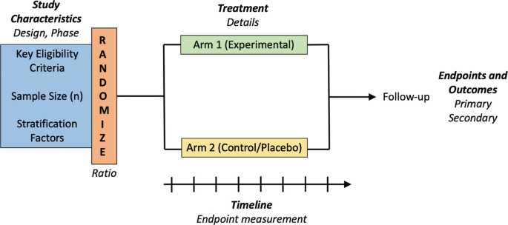
Study Population | < Details of the population to be included in the study>
Inclusion Criteria: | <In order to be eligible to participate in this study, a subject must meet all of the following criteria. Ethically, investigator should always include only participants that are likely to get benefit from the study intervention>
Exclusion criteria | <A potential subject who meets any of the following criteria will be ineligible to participate in the study. Ethically, investigator should always exclude participants that are likely to be harm from the study intervention e.g., drug allergy, having contraindication, underlying diseases.>  ***Do not defining exclusion criteria as the direct opposite of inclusion criteria***
Discontinuation/withdrawal criteria: | < Details of the criteria that participants need to stop study drug procedure to safety reason e.g., side effect of treatment, participant request, or progression of disease that required standard treatment.>  ***discontinuation criteria will relate to events happened after enrollment and mainly for participants’ safety, please do not confuse with exclusion criteria***
Study Interventions/ procedures | Provide the name or a phrase that describes the intervention.  ***The following details need to be sufficient to allow replication***
 | Why | Describe any rationale, theory, or goal of the elements essential to the intervention.
 | Materials | -Describe any physical or informational materials used in the intervention,  -Provide citation(s) on where more information of the materials can be accessed (e.g. online appendix, URL).
 | Procedures | Describe each of the procedures, activities, and/or processes used in the intervention, including any enabling or support activities.
 | Who provided | For each of intervention provider (e.g. surgeon, psychologist, physical therapist, nursing assistant), describe their expertise, background and any specific training given.
 | How | Describe the modes of delivery (e.g. face-to-face or by some other mechanism, such as internet or telephone) of the intervention and whether it was provided individually or in a group.
 | Where | Describe the type(s) of location(s) where the intervention occurred, including any necessary infrastructure or relevant features.
 | When and How much | Describe the number of times the intervention was delivered and over what period of time including the number of sessions, their schedule, and their duration, intensity or dose.
 | Tailoring | If the intervention was planned to be personalized, titrated or adapted, then describe the decision criteria and how to do so.
 | Modifications | If the intervention was modified during the course of the study, describe the changes (what, why, when, and how).
Comparator/Control | <provide details of comparator/control in details to allow replication  If control group is standard treatment/routine care, please provide adequate details of such standard treatment/routine care.>  please provide justification for using such comparator/control especially sham procedure >
Sequence generation | Provide following information  - Who will generate the random allocation sequence and the method used  - Type of randomization (simple or restricted) and details of any factors for stratification. To reduce predictability of a random sequence, other details of any planned restriction (for example, blocking) should be provided in a separate document that is unavailable to those who enroll participants or assign interventions
Allocation concealment mechanism | Provide following information  - Mechanism used to implement the random allocation sequence (for example, central computer/telephone; sequentially numbered, opaque, sealed containers), describing any steps to conceal the sequence until interventions are assigned.
Implementation | Provide following information  - Who are the personnel who will enroll research participants?  - Who will assign participants to the interventions?  - Who will have access to the random allocation sequence?
Blinding (masking): | - Describe who will be blinded after assignment to interventions (e.g., trial participants, care providers, outcome assessors, data analysts), and how  - If blinded, circumstances under which unblinding is permissible, and procedure for revealing a participant’s allocated intervention during the trial e.g., having serious adverse event.
Participant timeline and Procedures: | - Provide time schedule of enrolment, interventions (including any run-ins and washouts), assessments, and visits for participants.  - Please indicate any visit(s)/test(s) is standard/routine and any visit(s)/test(s) is for the purpose of research  - A schematic diagram or table is highly recommended.  For example:  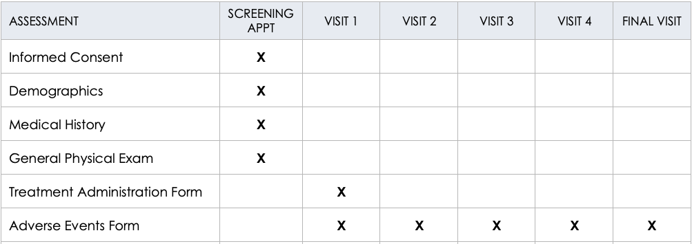
Outcomes/endpoints: | - Describe primary, secondary, and other outcomes, including the specific measurement parameters/variables and time point for each outcome according to objectives.  - Explanation of the clinical relevance of chosen efficacy and harm outcomes is strongly recommended.  Choosing clinical outcome as primary outcome is highly recommended in clinical trial that may increase significant health risks or burdens to participants and their families. Using surrogate outcome may be disapproved due to unbalance risk/benefit ratio.
Harms/risks: | Describe how harms/risk are defined and will be assessed, and how these could be managed. Also, in this section should be listed safety measures, as identified in laboratory findings, methods and timing for safety parameters based on the risk profile,
Adverse Event Reporting: | < This section should list any expected adverse events. Any toxicities seen in earlier studies should be mentioned here. definitions for adverse events (AE) and serious adverse events (SAE) and laboratory values used to identify their possibility, time frames for reporting and collecting information on AEs and SAEs, the reporting system, how AEs will be followed up on, and what the specific guidelines for independent monitoring.>
Trial monitoring: | Explanation of any interim analyses and stopping guidelines, including details of data monitoring committee (DMC); summary of its role and reporting structure; statement of whether it is independent from the sponsor and funder; conflicts of interest.  Alternatively, an explanation of why a DMC is not needed.
Data collection methods: | Plans for assessment and collection of trial data, including any related processes to promote data quality (for example, duplicate measurements, training of assessors) and a description of trial instruments (for example, questionnaires, laboratory tests) along with their reliability and validity,  *** Data collection forms/case record form (CRF) must be included as a separate document. ***
Compliance and adherence | Plans to promote participant retention and complete follow-up.
Sample size determination: | - The number of subjects should always be large enough to provide a reliable answer to questions addressed. Also, the size of detectable differences should be of clinical relevance.  - The number of subjects is usually determined by the primary objective of the trial. If the sample size is determined on some other basis, then this should be clearly described and provide justification.  - There are many formulas to calculate the size of the study population. It should be clear which method is used and the reasons why this method has been chosen. For non-inferiority clinical trial, sample size should be calculated based on clinical-relevant non-inferior margin.  - Suggest to seek advice from a statistician to help you with this matter.  *** Method and references for data used for sample size calculation are required ***
Statistical Analysis Plan: | Describe  - Statistical methods used to compare groups for primary and secondary outcomes (as described in objectives).  - How missing data will be handled.  - how the data will be statistically analysed, including information on analysis population (e.g., intention-to-treat or per protocol) to be included in the analyses.  - Planned subgroup analysis should be described here.  It is recommended to consult a biostatistician for details in this section. Deviation from the protocol may be considered as data falsification.>
Recruitment procedure: | - Explain strategies for achieving adequate participant enrolment to reach target sample size.  - Please specify means to recruit participant e.g., poster, social media, personal contact.  - The patient advertisement document e.g., letter, poster must be attached as a separate document.
Informed Consent Process: | Please give a description of the recruitment and informed consent procedures.  - How, when, where and by whom (investigator, supervising doctor, other person) will subjects be informed about the study and asked for their consent?  - In participants with presumed limited decision capacity (e.g. dementia, sedated, encephalopathy), assessment of cognitive function or seeking consent from legally authorised representative are needed.  - How much time will they be given to consider their decision?  <The informed consent form must be attached as a separate document.>  <For study in children and adolescent age 7 to 18 years, assent with languages appropriate for ages must be included as separate documents.>
Privacy and confidentiality (Data Management Plan) : | According to Thai Personal Data Protection Act 2019, this section is mandatory.  - Who will be responsible for data management?  - How will new data be collected or generated?  - What data (for example the kind, formats), will be collected or generated?  - How will the data be organized and recorded to ensure for both quality control and reproducibility?  - How will data be stored and backed up during the research?  - How will data security and protection of sensitive data be taken care of during the research?  - How will compliance with legislation on personal data and on security be ensured If personal data are collected, stored, or processed?  - Who, which investigators and research staff, will have access to biospecimens and data?  - How will data access be controlled?  - Any plans for sharing or providing access of the data to others outside Mahidol University. Data sharing agreement will be required.  - Outline the plan for data preservation and give information on how long the data will be retained.
Ethical consideration: | - Risks to participants and how to minimize the risks:  <Identify any risks and burdens involved while conducting the study and procedure to minimize such risk/burden>  - Direct Benefits to Participants  < A direct benefit refers to a health advantage experienced by current participants as a direct result of the intervention in the study. It does not include the potential for knowledge gain, benefits to future patients, routine clinical services/treatment/testing, unnecessary clinical services/tests, or monetary compensation. Please do not overclaim.>  - Scientific or social value  <Include potential knowledge advancement or application to the society.>  Example: This study does not present the prospect of direct benefit to the participants. However, the study does provide an opportunity to gain a better understanding of……  - Justification if enrolling potentially vulnerable subjects.  <Please specify the justification for enrolment of children and/or incapacitated adults participating in research especially clinical trial that does not provide direct health benefit. This should also be specified in the informed consent.>  Travel compensation and compensation for injury  <Please describe any special incentives, compensation, or treatment that subjects will receive through participation in the study.>  - Plan of board consent  <Plans for collection, laboratory evaluation, and storage of biological specimens for genetic or molecular analysis in the current trial and for future use in ancillary studies, if applicable>
Study Timeline: | <Provide timetable of the study>  For Example:  screening, enrollment, ----6 months from January 20xx to June 20xx  treatment phase -----6 months from …  data collection and data analysis -----2 months from ….
Budget: | <Describe planed budget for each category e.g., study-related care, study intervention, laboratory testing, participant travel compensation.>
References: | <List all the references used in the background section at the end of the protocol. Vancouver or AMA style is preferred.>

Signature..................................................... Principal Investigator
(...................................................)
Date......................................................

Signature..................................................... Major Advisor (if any)
(...................................................)
Date......................................................

