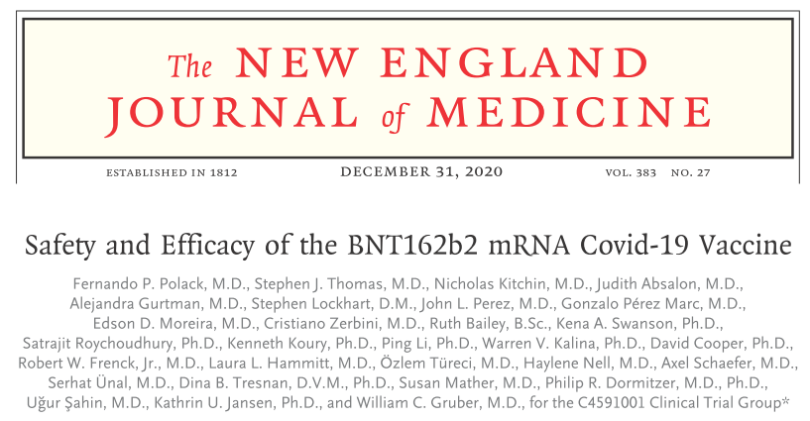

We previously reported phase 1 safety and immunogenicity results from clinical trials of the vaccine candidate BNT162b2, **1** a lipid nanoparticle formulated, **2** nucleoside-modified RNA (modRNA)**3** encoding the SARS-CoV-2 full-length spike, modified by two proline mutations to lock it in the prefusion conformation. **4** Findings from studies conducted in the United States and Germany among healthy men and women showed that two 30-μg doses of BNT162b2 elicited high SARS-CoV-2 neutralizing antibody titers and robust antigen-specific CD8+ and Th1-type CD4+ T-cell responses.**5** The 50% neutralizing geometric mean titers elicited by 30 μg of BNT162b2 in older and younger adults exceeded the geometric mean titer measured in a human convalescent serum panel, despite a lower neutralizing response in older adults than in younger adults. In addition, the reactogenicity profile of BNT162b2 represented mainly short-term local (i.e., injection site) and systemic responses. These findings supported progression of the BNT162b2 vaccine candidate into phase 3.

1. **Title:** Safety and immunogenicity of two RNA-based Covid-19 vaccine candidates.

**Authors:** Walsh EE, Frenck RW Jr, Falsey AR, et al.

**Journal:** N Engl J Med 2020

2. **Title:** Expression kinetics of nucleoside modified mRNA delivered in lipid nanoparticles to mice by various routes.

**Authors:** Pardi N, Tuyishime S, Muramatsu H, et al.

**Journal:** J Control Release 2015

3. **Title:** Incorporation of pseudouridine into mRNA yields superior nonimmunogenic vector with increased translational capacity and biological stability.

**Authors:** Karikó K, Muramatsu H, Welsh FA, et al.

**Journal:** Mol Ther 2008

4. **Title:** Cryo-EM structure of the 2019-nCoV spike in the prefusion conformation.

**Authors:** Wrapp D, Wang N, Corbett KS, et al.

**Journal:** Science 2020

5. **Title:** BNT162b2 induces SARS-CoV-2 neutralising antibodies and T cells in humans.

**Authors:** Sahin U, Muik A, Vogler I, et al.

**Journal:** medRxiv, 2020