User manual for making an appointment to consult the research (for Ramathibodi Hospital’s internal personnel)

Department of Clinical Epidemiology and Biostatistics

3rd Floor, Research Center Building, Faculty of Medicine Ramathibodi Hospital, Mahidol University  
270 RAMA VI Road. Rachathevi, Bangkok 10400, Thailand.

1. Logging in (it is highly recommended to access through Google Chrome), simply go through this link: [**https://med.mahidol.ac.th/ceb/**](https://med.mahidol.ac.th/ceb/).

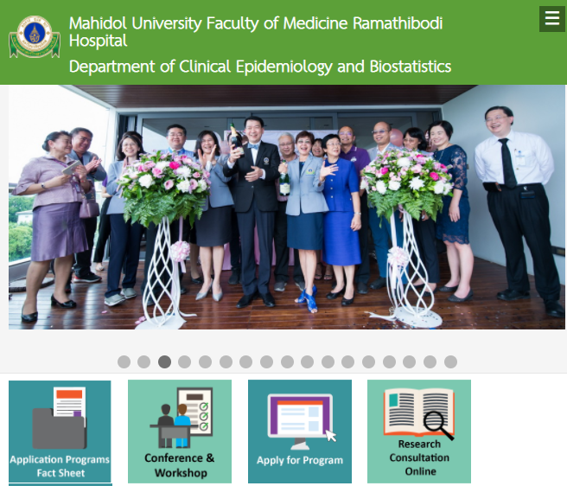

1. Select  to access the system by inputing your 6 digits ID as “Username” and password (same as the one using to access I HR Service).

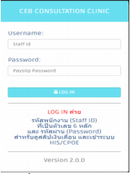** For cases with no 6 digits ID, please call 02-201-1284 to make an appointment**

1. Once logged-in, the page should look like this: 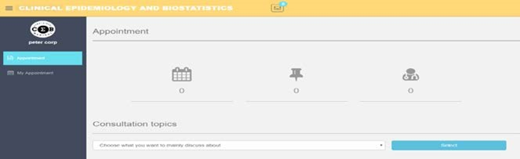

Simply make an appointment by specifying “Consultation topics”, once the topic was chosen. Then the system will automatically present those fields specialists. After the specialist is selected, then click “go to calendar” below his/her photo.

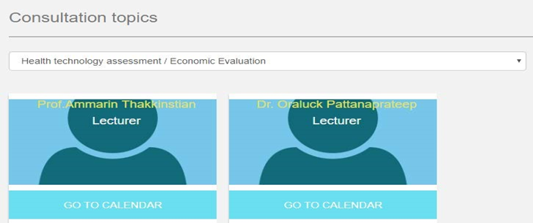

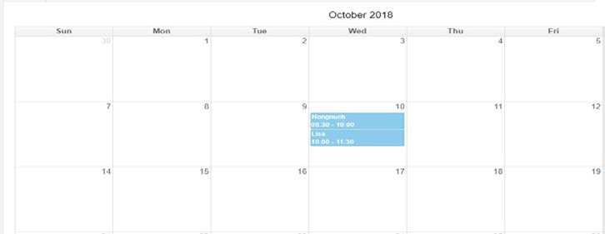Once click on “go to calendar”, then the system will automatically present his/her calendar as per below photo.

** Kindly note that, chosen specialist might not be assigned on a particular day. Hence, should you select any non-assigned date. The system will present similar notice as below photo.

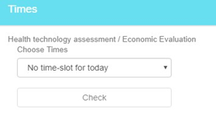

** Please also note that user cannot request 2 continuous appointments (including with appointments which are on waiting and confirm status).

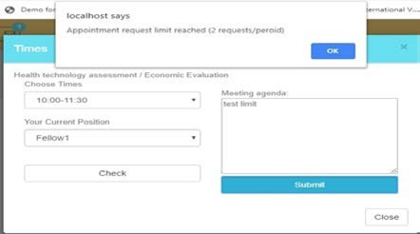  
  
*Also, please indicate your current position and meeting agenda into the system.

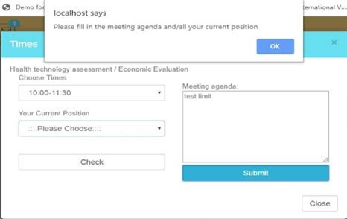  
  
*In case you could not attend previous two (2) continuous appointments, please specify no show reason. Otherwise, new appointment cannot be scheduled.

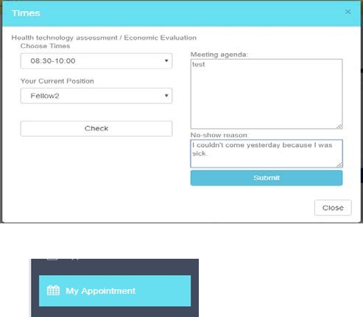

Find your reservation to check its status, should your reservation has not been confirmed. Then, the system should show “waiting” in yellow. Regardless, once your reservation is confirmed, the system will show “confirm” in green.

*****For any queries or difficulties, please do not hesitate to call us at 02-201-1284*****

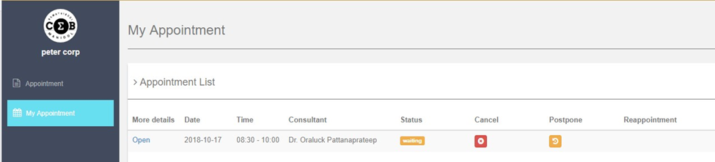

Cancellation, modification and reschedule:

For cases of cancellation, click on the red button ,

For cases of modifying the reservation, click ,

For cases of reschedule, click 

**For reschedule, please specify the reason under comment’s section. Then click “Yes”, the system will later present the calendar’s page to make a new reservation.

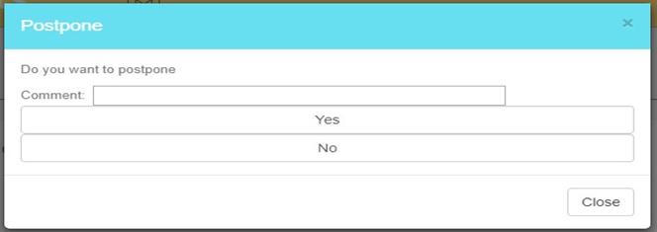

** If the system shows “postpone” on your reservation’s status, you can reschedule by clicking on .

To log out from the system, click on this blue button .